Outlining the service architecture and key design decisions
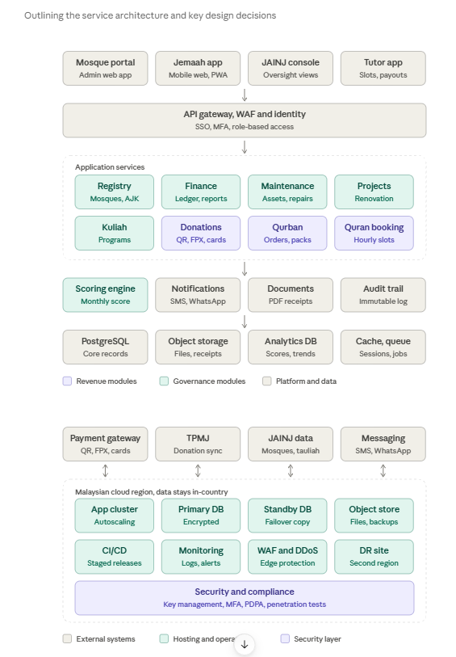

Layer | Choice | Why
Web and mobile | React or Next.js as a PWA, Bahasa Melayu first | One codebase for volunteers’ phones and desktops, works on weak connections
Backend | Node.js (NestJS) or Java (Spring Boot) modular monolith | Common skills in Malaysia, easy to split into services later
Database | PostgreSQL | Matches the schema already delivered; strong transaction integrity for finance
Cache and jobs | Redis with a job queue | Receipts, reminders and monthly scoring runs
Hosting | Government-approved cloud region in Malaysia, containers, infrastructure as code | Data residency and repeatable deployments
Payments | Licensed gateway with split settlement | Funds go to the mosque or tutor directly and the platform commission is deducted at source, so PIJ Holdings or the SPV never holds donor money
Suggested technology stack (all replaceable, none is a requirement):
Quran booking specifics. The booking module needs a slot engine that locks a time slot while a parent pays, so two families can’t book the same hour. Pricing is hourly rate multiplied by hours, with a tier by number of students. Tutor onboarding checks tauliah or equivalent credentials first, and bookings with minors need a guardian consent step.

Peak load. Traffic spikes on Fridays, in Ramadan and before qurban cutoffs. The design handles this with autoscaling, a change freeze before those periods, load tests in Phase 1, and the 99.5% availability target from the business plan.

Phasing.

Phase 1 delivers Registry, Finance, Maintenance and Kuliah plus the gateway, identity and core data stores. Donations, Qurban and Quran booking follow in
Phase 2, and the Scoring engine and analytics store in
Phase 3, matching the funding gates.

